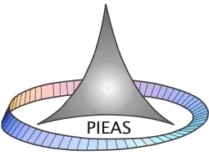

Fall

-

2020



PAKISTAN INSTITUTE OF ENGINEERING AND APPLIED SCIENCES

Computer Fundamentals and

Programming

**Report: Lab 02**

**Name: Umar Shifaqat**

**Department: DPAM Roll No. BS-20-GB-100864**

**Date: 7 October,2020.**

# Activity 1

**Write a program to compute and display the volume of a cylinder with following measurements.**

**h=12cm, r=7cm**

## INPUT

#include<stdio.h> int main()

{

float Pi,radius,height,volume; Pi=3.1415 ; radius=7 ;//cm height=12 ;//cm volume=Pi*radius*radius*height; //cm^3

printf(" In a cylinder,\n If the radius =7cm and height =12cm;\n The Volume of Cylinder will be %f

cm^3",volume);

getchar(); getchar(); return

0;

}

Here is shown the screenshot of the above program and its executable file.

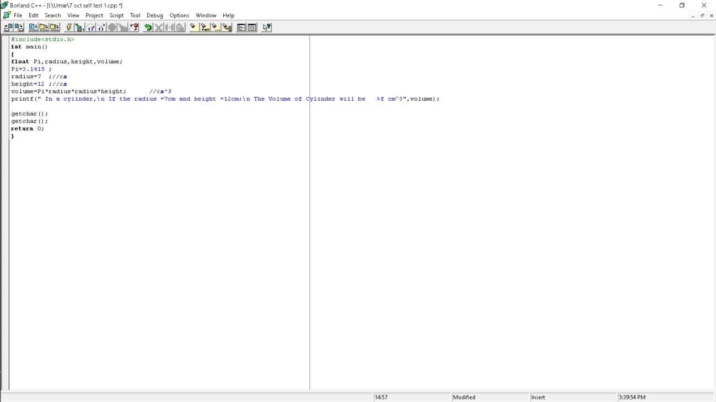

Here is shown the executable file of the above program

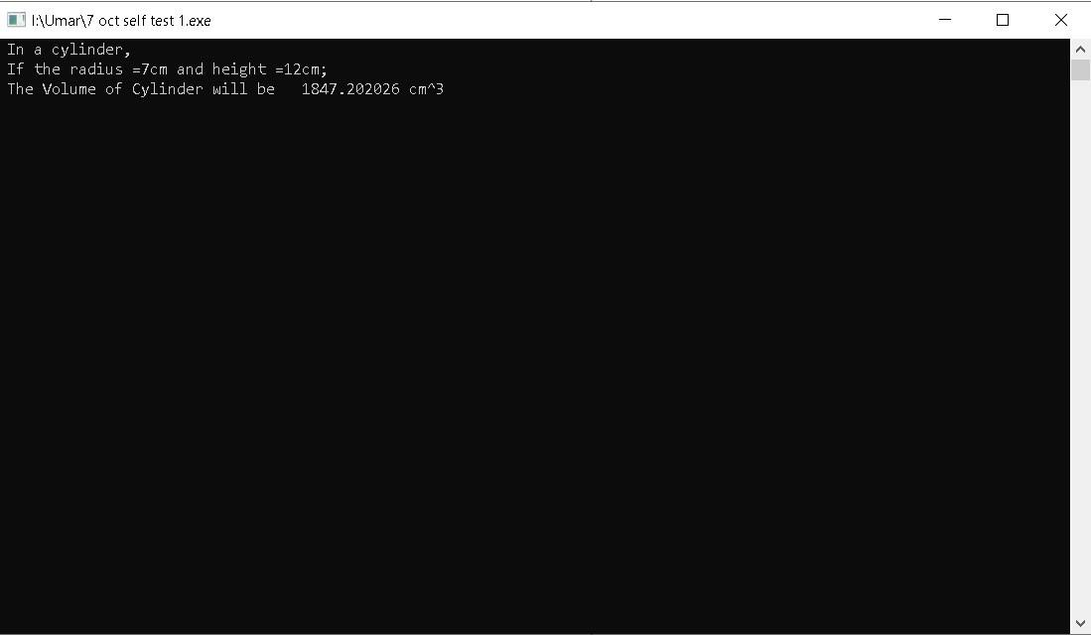

The figure above shows the volume of cylinder for the given input.

**Activity 2**

**Try to predict the value x in following statements, write programs to verify your answers.**

**1. x=12/5 where x is an integer variable**

The value of x will be 2.

## INPUT

#include<stdio.h> int main()

{ int x,y,z;

y=12,z=5; x=y/z; printf("The value of x is

%d",x);

getchar(); return

0;

}

The screenshot of the program above is:

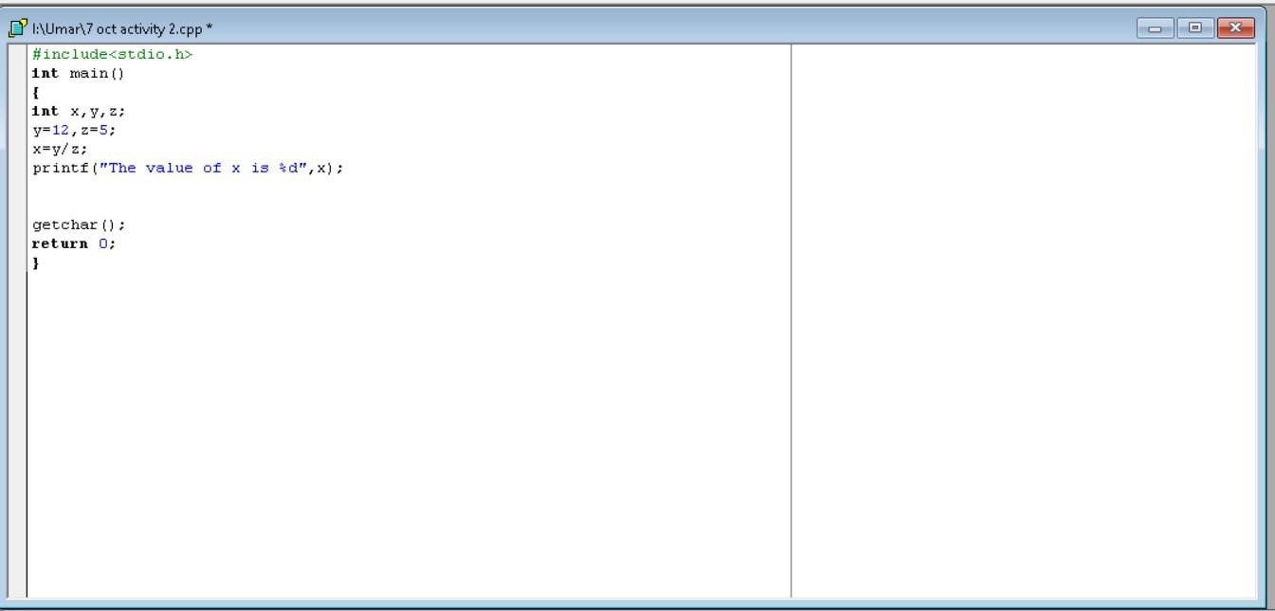

The executable file of the program above is :

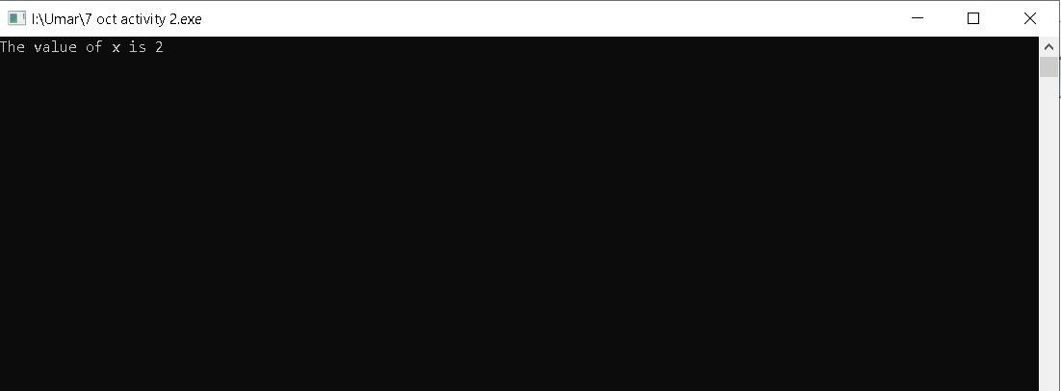

**2. x=39/6 where x is a float variable**

The value of x will be 6.

## INPUT

#include<stdio.h> int main()

{

float x,y,z;

y=39,z=6; x=y/z; printf("The value of %s is %f","x",x);

getchar(); return

0;

}

The screenshot of the above program is:

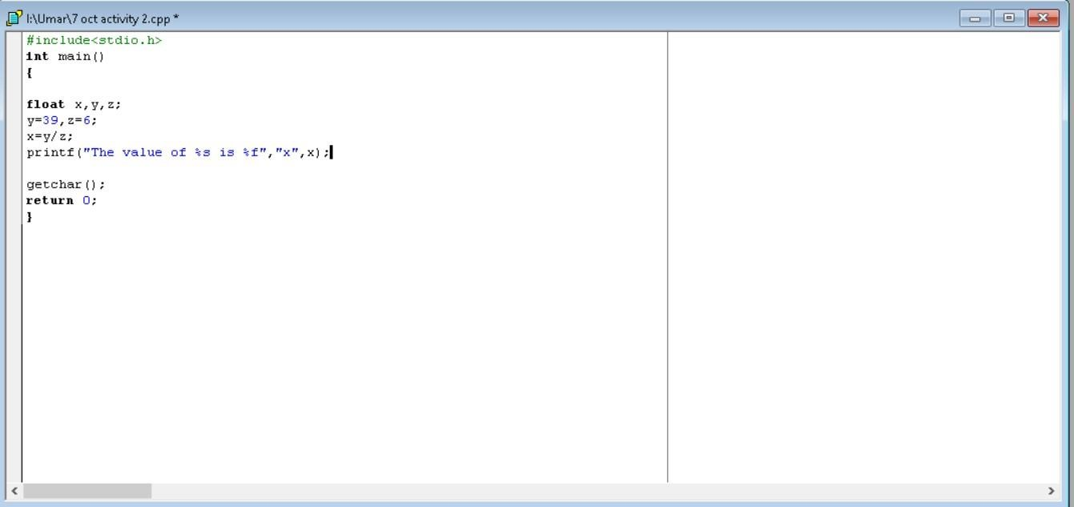

The executable file of the program above is:

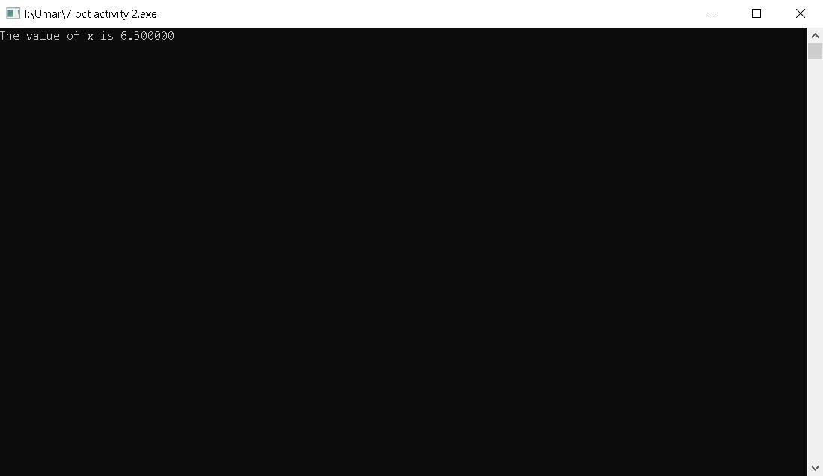

**3.**  **x=45/7.0 where x is a float variable**

The value of x will be 6.428.

## INPUT

#include<stdio.h> int main()

{

float x=45/7.0; printf("The value of x is %f",x); getchar(); return 0;

}

The screenshot of the program is:

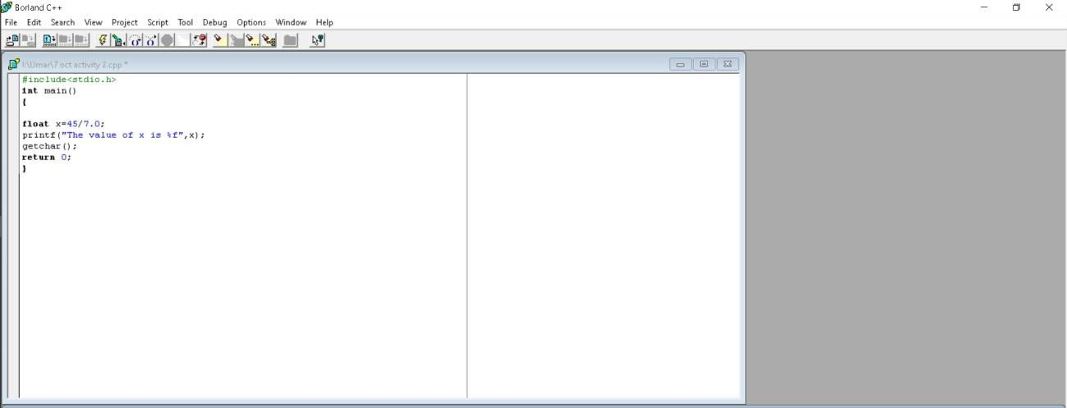

The screenshot of the executable file of the above program is:

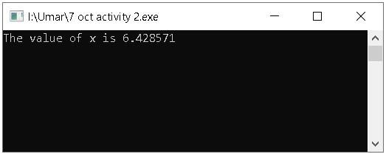

# Activity 3

**Write a program that asks the user to enter a value for x and then displays the value of the following polynomial (8x2 -4x) + (2x).**

## INPUT

#include<stdio.h> int main()

{

float x,y;

printf("Enter the value of variable x\t");

scanf("%f",&x);

y=(8*x*x-4*x)+2*x;

printf("The value of polynomial (8x^2-4x)+ 2x is %f",y);

getchar(); getchar(); return

0;

}

The screenshot of the above program is:

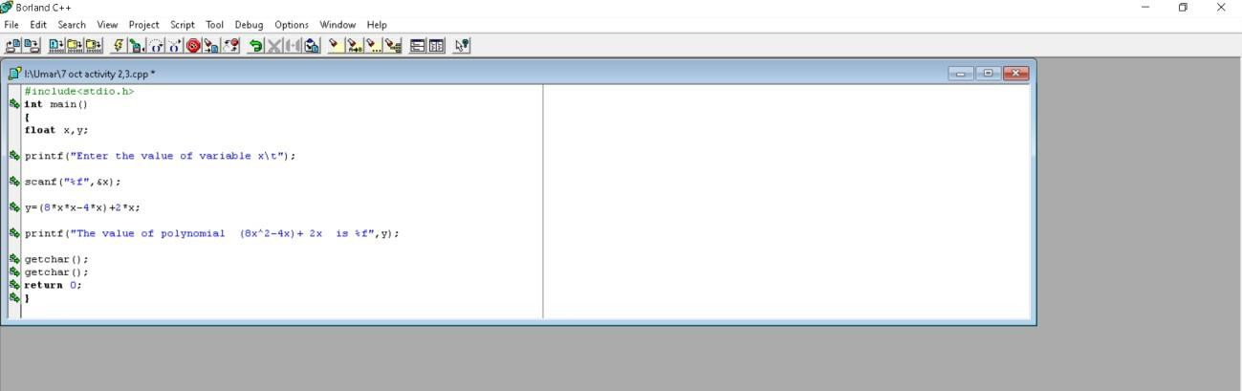

The screenshot of the executable file of the above program is:

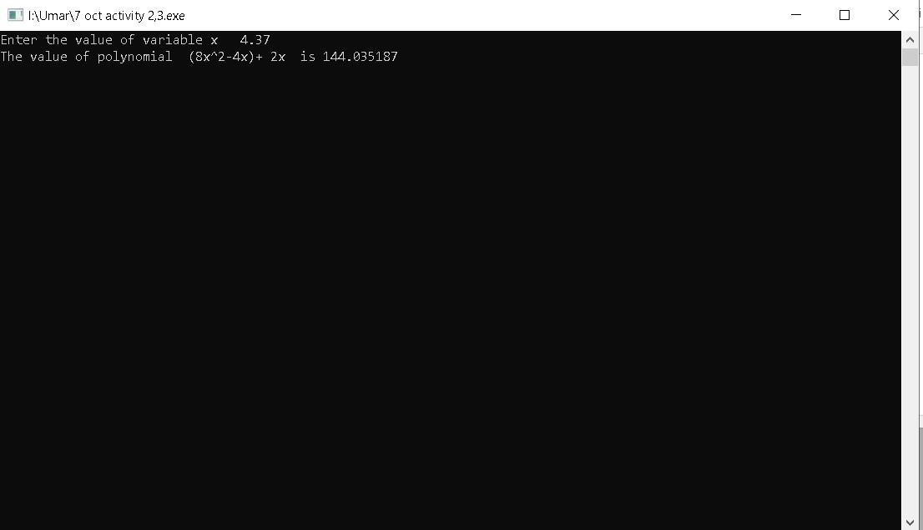

So, this is the program that gave us the value of polynomial for the value of x=4.37 given by the user.

# Activity 4

**Write a program to calculate the total cost of the vehicle by adding basic cost with (i) excise duty (15%) (ii) sales tax (10%) (iii) octroi (5%) and (iv) road tax (1%). Input the basic cost by user.**

## INPUT

#include<stdio.h> int main()

{

float basic_cost,excise_duty,sales_tax,octroi,road_tax,total_cost; printf("\tEnter the Basic Cost of the Vehicle: Rs/- ");

scanf("%f",&basic_cost);

excise_duty=basic_cost*15/100; sales_tax=basic_cost*10/100; octroi=basic_cost*5/100; road_tax=basic_cost*1/100;

total_cost=basic_cost+excise_duty+sales_tax+octroi+road_tax;

printf("\n\tThe Total Cost of the Vehicle is Rs/- %f.",total_cost); getchar(); getchar(); return 0;

}

The screenshot of the above program is:

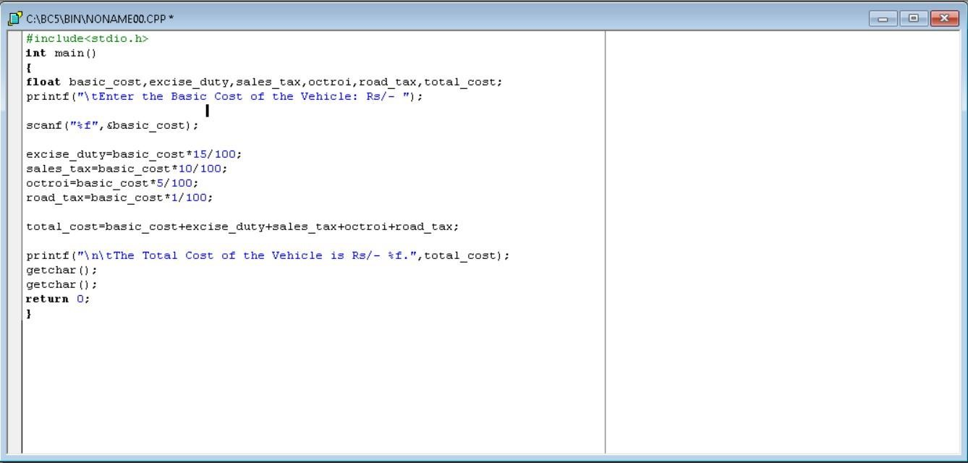

The screenshot of the executable file of the above program is:

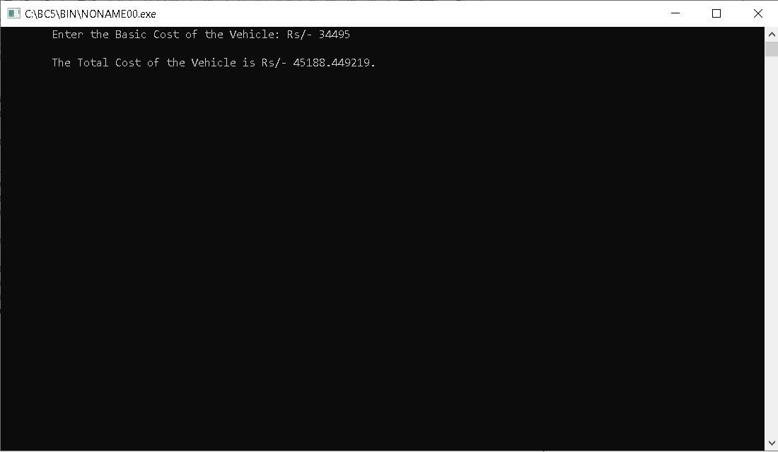

The above figure shows the total cost of vehicle on the basis of the basic cost=34495.

# Activity 5

**A car is travelling with a velocity of 45 km/hour , how much time will it take to reach its destination which is 700 km from starting point, represent the time in hours, minutes and seconds.**

## INPUT

#include<stdio.h> int main()

{

float v,s,t; int t1,t2,t3; v=45; s=700; t=s/v; t1=t; printf("The time taken by the car is %d hour/s\t",t1); t2=(t-t1)*60; printf("%d minute/s",t2); t3=3600*(tt1)-60*t2; printf(" and %d second/s.",t3); getchar(); getchar(); return 0;

}

The screenshot of the above program is:

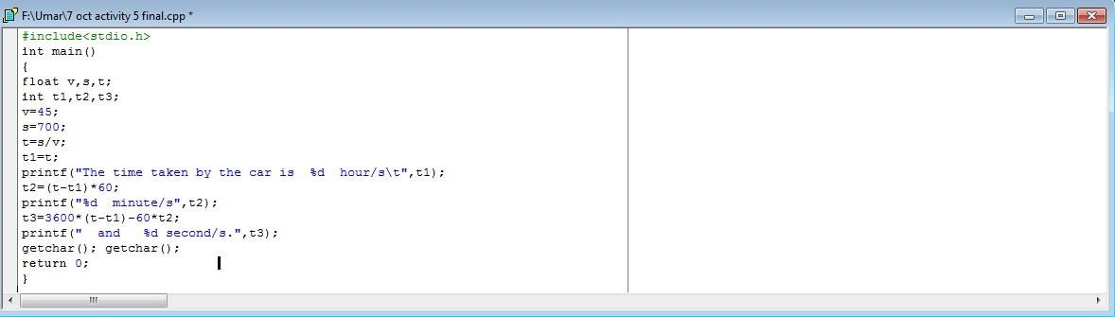

The screenshot of the .exe file of the above program is :

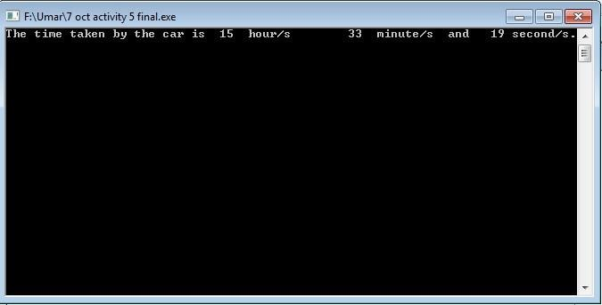

The figure above shows the time in hours, minutes and seconds for the given input.

**2(b) Modify the above program such that it can find the time for any given velocity V and distance S, the values of S and V are provided by the user as input.**

## INPUT

#include<stdio.h> int main()

{ float v,s,t; int t1,t2,t3; printf("Enter the velocity of car in km/hour : "); scanf("%d",&v); printf("Enter the distance travelled by car in km : "); scanf("%d",&s); t=s/v; t1=t; printf("The time taken by the car is %d hour/s\t",t1); t2=(t-t1)*60; printf("%d minute/s",t2); t3=3600*(t-t1)-60*t2; printf(" and %d second/s.",t3); getchar(); getchar(); return 0;

}

The screenshot of the above program is :

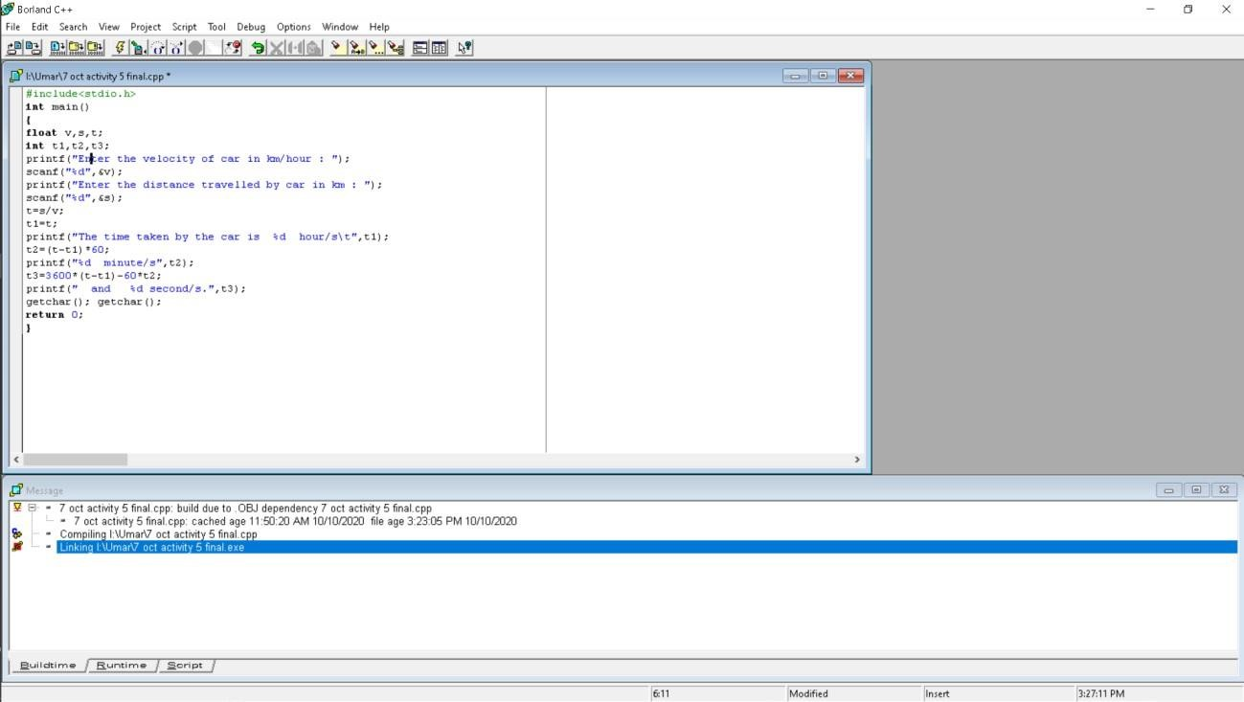

The screenshot of the executable file of the above program is :

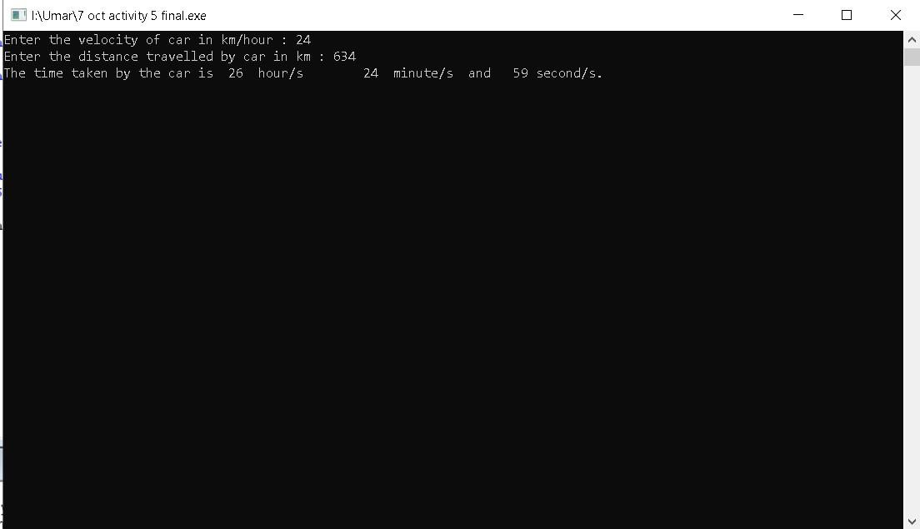

Above figure shows the time ion hours, minutes , seconds for the input by the user velocity 24 and distance 634.

# Activity 6

**Write a program to solve the following equation for values of a and b. ( a+b )2 = ( a2 + b2 + 2ab )**

## INPUT

#include<stdio.h> int main()

{

int a,b,R,L; printf("Enter the vale of a :"); scanf("%d",&a); printf("Enter the value of b :"); scanf("%d",&b); L=(a+b)*(a+b); printf("%s=%d","(a+b)^2",L); R=a*a+b*b+2*a*b; printf("\n%s=%d","a^2+b^2+2ab",R); printf("\n Hence, (a+b)^2 = a^2+b^2+2ab"); getchar(); getchar(); getchar(); getchar(); return 0;

}

The screenshot of the above program is :

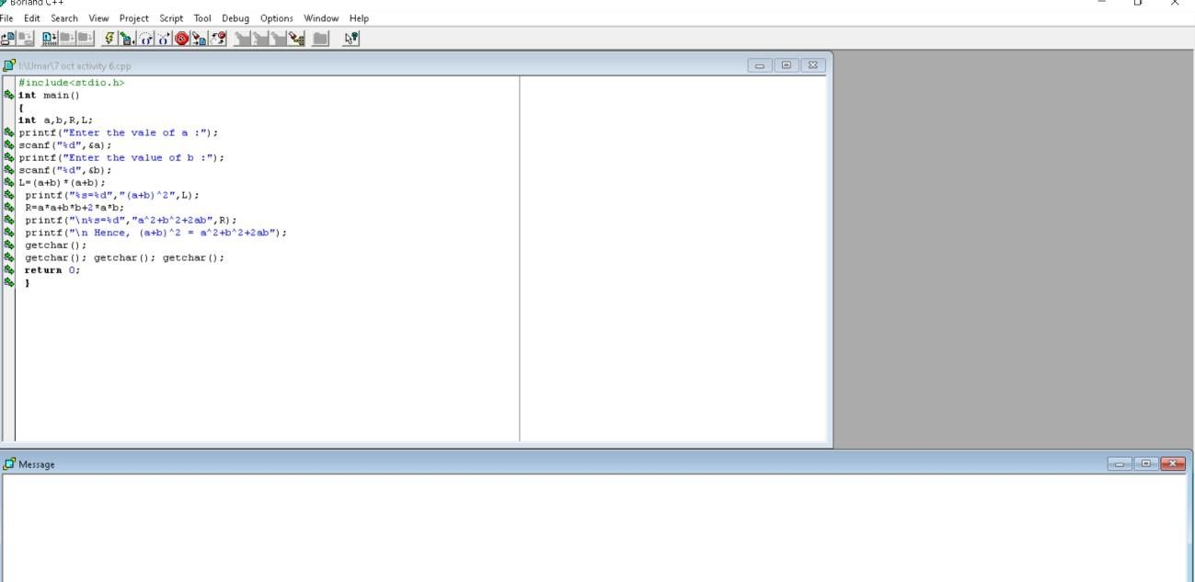

The screenshot of the executable file of the above program is :

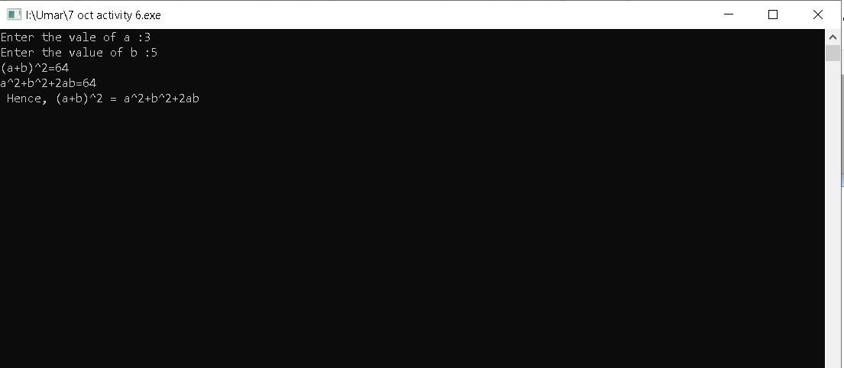

Above figure shows shows that (a+b)2 = ( a2 +b2 +2ab ) .

# Activity 8

**Get two numbers X and Y from the user and print the remainder of x**

**% y.**

**INPUT**

#include<stdio.h> int main()

{

int x,y,remainder; printf("Enter the value of x:",&x); scanf("%d",&x); printf("\nEnter the value of y:",&y); scanf("%d",&y); remainder=x%y; printf("\nThe remainder is

%d",remainder);

getchar(); getchar(); getchar(); getchar(); return 0;

}

The screenshot of the above program is:

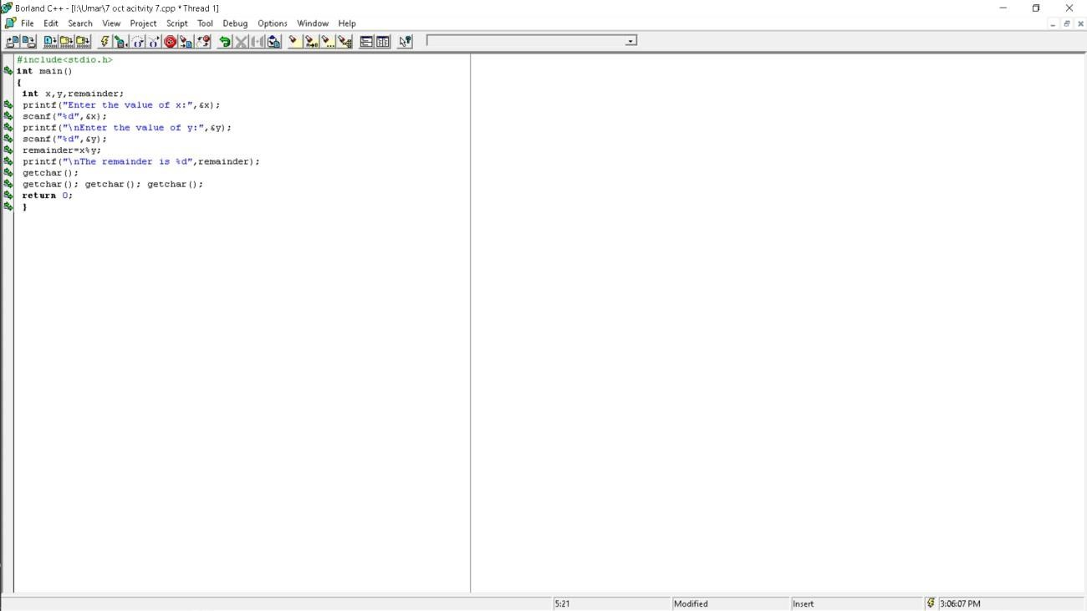

The screenshot of the executable file of the above program is :

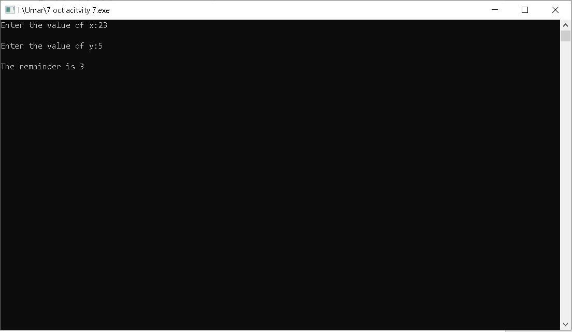

Above figure shows the quotient for the input by the user: x=23, y=5.

**Home Tasks**

# Task 1

**Write a program that prompts user for two integers and print their sum, difference, product, quotient, reminder, Square root of each number separately, Pow of number1 to number 2 (number1 ^ number**

**2).**

## INPUT

#include<stdio.h> #include<math.h> int main()

{

int number_1,number_2,sum,difference,product,quotient,reminder,exponent;

float square_root; printf("Enter the first

number here:"); scanf("%d",&number_1);

printf("\nEnter the second number here:"); scanf("%d",&number_2);

sum=number_1+number_2;

printf("The sum is %d.\n",sum);

difference=number_1-number_2; printf("The difference is %d.\n",difference); product=number_1*number_2; printf("The product is %d.\n",product); quotient=number_1/number_2; printf("The quotient is %d.\n",quotient);

reminder=number_1%number_2;

printf("The reminder is %d.\n",reminder);

square_root=sqrt(number_1); printf("The square root of first number is %f.\n",square_root); square_root=sqrt(number_2); printf("The square root of second number is %f.\n",square_root);

exponent=pow(number_1,number_2);

printf("The exponent of first number to second number is %d",exponent);

getchar(); getchar(); return

0;

}

The screenshot of the above program is:

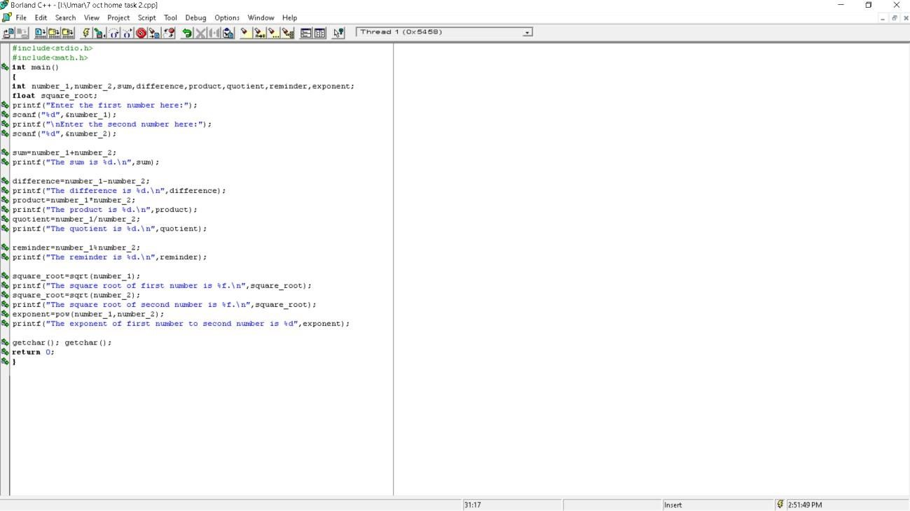

The screenshot of the executable file of the program is:

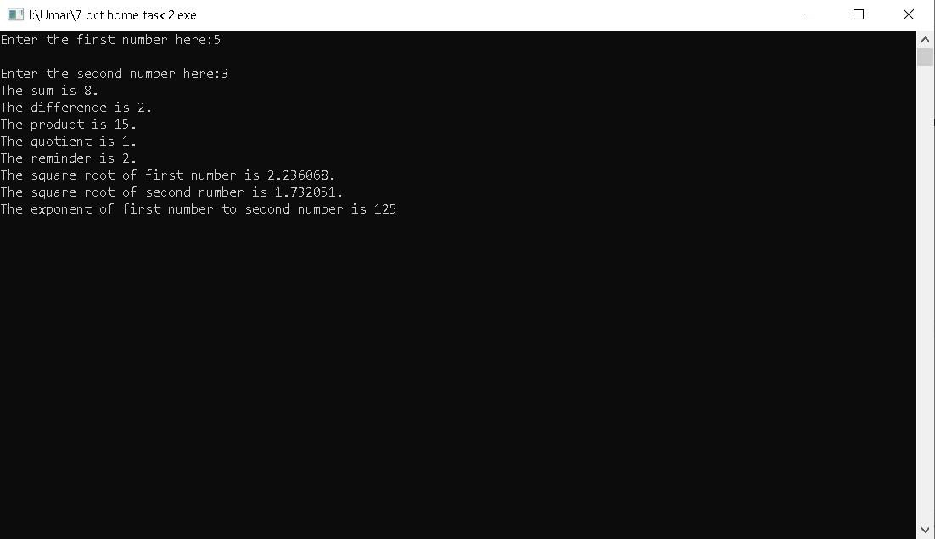

Above figure shows the sum, difference, product, quotient, reminder, square and exponent for the values given by the user 5 and 3 .

# Task 2

**Zain’s basic salary is input through the keyboard. His dearness allowance is 30% of basic salary, and house rent allowance is 30% of basic salary. Write a program to calculate and display the total allowances and his gross salary.**

## INPUT CODE

#include<stdio.h> #include<math.h> int main()

{

float basic_salary,dearness_allowance,house_rent_allowance,total_allowance,gross_salary; printf("Enther the basic salary here:Rs/_ "); scanf("%f",&basic_salary);

dearness_allowance=30.0/100*basic_salary;

house_rent_allowance=30.0/100*basic_salary;

total_allowance=dearness_allowance+house_rent_allowance;

printf("\nThe total allowance of Zain's salary is Rs/_ %f.\n\n",total_allowance);

gross_salary=basic_salary+total_allowance;

printf("The total salary/ gross salary of Zain is Rs/_ %f.",gross_salary); getchar(); getchar(); return 0;

}

The screenshot of the program is below:

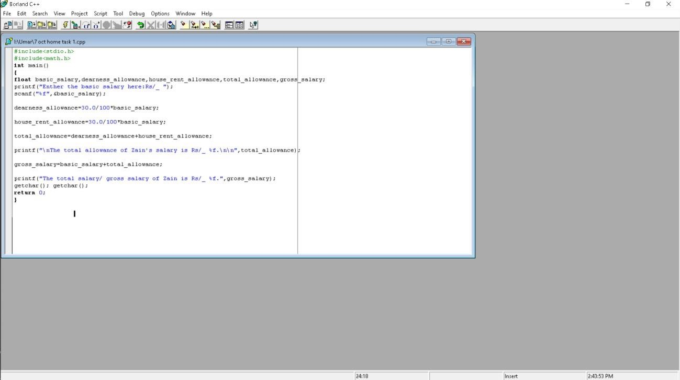

The executable file of the above program is below:

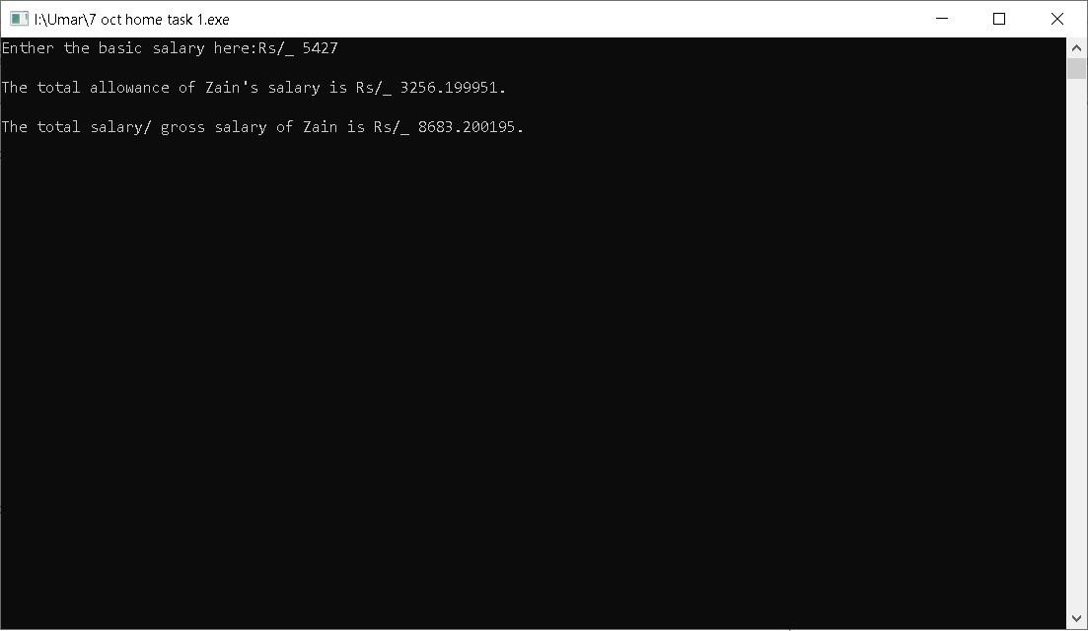

Above figure shows the total allowance and the gross salary of Zain for the value of the basic salary input by the user 5427.